DIRECTORATE OF INDUSTRIAL TRAINING, MINISTRY OF EDUCATION AND SPORTS
APPLICATION FORM FOR ADMISSION TO AN ADVANCED CERTIFICATE OF COMPLEMENTARY AND ALTERNATIVE MEDICINE

- ONE fully filled copy should be filled by the applicant and Returned to Aloesha Organic Training Institute to the Office of the Principal with the original application fee receipt attached.
- Filling this form means you have successfully passed the criteria for admission to the institute.
TO BE COMPLETED FOR ACADEMIC YEAR: ………………………………………………………
Fill this form in Capital Letters
Names must be those that appear in the applicants previous academic/national documents
- Level/Module applied for: …………………………………………………………………………….

- Surname: ………………………….............. Other Name(s): …………………..................

- Gender: Male: Female:
- Marital Status: ……………… District of Origin: …………………… Citizenship: ………….

- Date of Birth: …………………….. Age: ……………… Place of Birth: ………………………..
- Personal Tel: ………………………………………… Email: ………………………………….

- ID Type: ………………………… NIN: ……………………………………………………………...

- Next of Kin 1 ……………………………………R/ship: ……………….......Tel: ………….………..
Next of Kin 2: …………………………………...R/ship: …………………...Tel: …………………..

- PERSONAL HEALTH
Please describe any medical condition that you face. Failure to disclose, the institute will not be held liable of any consequences that may arise from an unknown health issue.
Medical Problem | Do’s/Don’ts | Known First Aid
NB:
In a case of minor accidents/illnesses, the institute administration will have to foot the medical bill in reference to a medical fee paid and additional support, however, for a case of severe accidents in or outside the institute, severe fire burns, or results of chronic illness, the institute administration will only share partial liability of the victim with his/her parent of guardian.
- EDUCATION BACKGROUND
NO | LEVEL 1 | SUBJECT | GRADE | AGG/DIV | SCHOOL/INSTITUTE
1 | PRIMARY | ENG
 |  | MATH
 |  | SST
 |  | SCIENCE
2 | O' LEVEL | SUBJECT | GRADE | AGG/DIV | SCHOOL/INSTITUTE
 |  | ENG
 |  | MATH
 |  | CHEM
 |  | BIO
 |  | PHYSICS
 |  | HIST
 |  | GEOG
3 | A' LEVEL | COMBINATION SUBJECTS | GRADE | POINTS | SCHOOL/INSTITUTE
 | (Fill Subjects)
 | 1 | ICT
 | 2 | G/P
 | 3
 | 4
 | 5
4 | HIGHER EDUCATION (tick) | LEVEL | Name of Course
 |  | CERTIFICATE
 |  | DIPLOMA
 |  | DEGREE
 |  | POST-GRAD

- INSTITUTE’S RULES AND REGULATIONS
Breaking any of these rules will lead to serious disciplinary action taken against you or dismissal from the training institute
- Tuition fees must be paid with in first 2 weeks at the beginning of each semester .Students who cannot afford to pay once will be allowed to pay in 2 instalments by the end of the second month the semester. Failure to do so will lead to suspension until the payment is made.
- Training sessions are from Monday to Friday 8:00am up to 4:00pm .punctuality shall be insisted on, late coming is not allowed.
- Attendance to class by all students is compulsory. Prior permission must be sought for absence.
- No visitor is allowed to meet any trainee during class hours.
- No smoking , taking drugs, alcohol , glue sniffing is prohibited
- Misconduct and indiscipline of any kind like fighting, quarrelling, cheating, stealing is forbidden by the center. Every student must respect every member/staff of Aloesha organic training center and are expected to be polite, courteous, obedient and cooperative to their fellow students.
- Any student proved guilty of stealing the property belonging to anybody or to the center will be dealt with seriously and may lead to dismissal.
- No student should damage, break or lose the center property. In case of any incidence the property will be paid for or physically replaced by the student. Students are advised to take care of their properties. The center will not be responsible if any student’s belongings get lost.
- All students must dress decently in agreed colors during school hours.
- Mobile phone should be strictly switched off during class hours as well as during practical exercises.
- All students advised to not to become pregnant during their course
- Students are expected to participate in various activities of the center and to assist in communal works.
- No student is allowed to use ingredients, materials, or equipment belonging to the center for personal use. Also selling plants or materials by student is forbidden.
- Students will have to keep classroom clean, toilets and school surroundings. Littering of rubbish is forbidden

- Any Student who by any means is involved in development of an herbal medicine product, he/she should not advertise in in the name of Aloesha Organic Natural products or Institute. Once found, the Organization will deal with the student and cancel his/her certification of training, in addition to suing the person in courts of law and NDA manufacturing guidelines

- FEES AND REQUIREMENTS
All fees/tuition payments must be made through the institute’s Centenary bank account 3100062435 in the names of ALOESHA ORGANIC TRAINING INSTITUTE LTD. No money should be handled over to any person as the institute will not be held responsible of the damages caused.
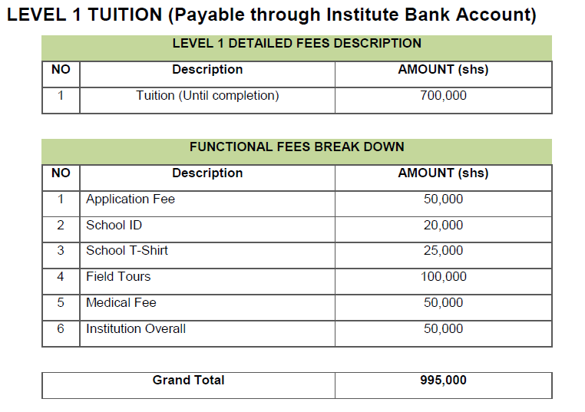
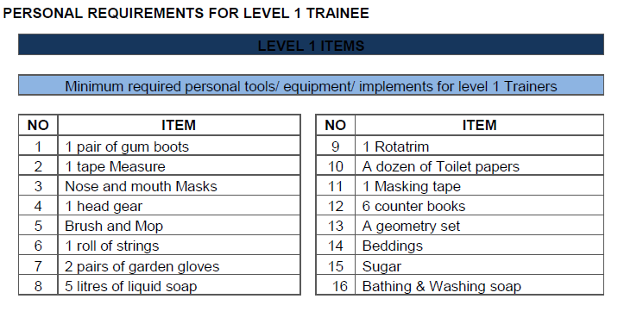
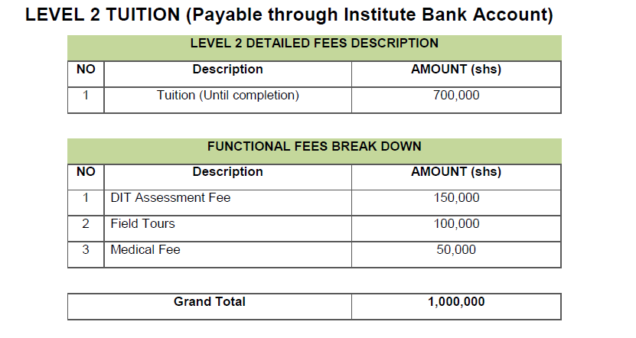
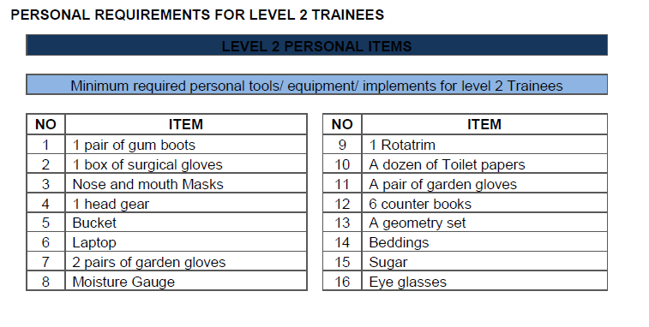
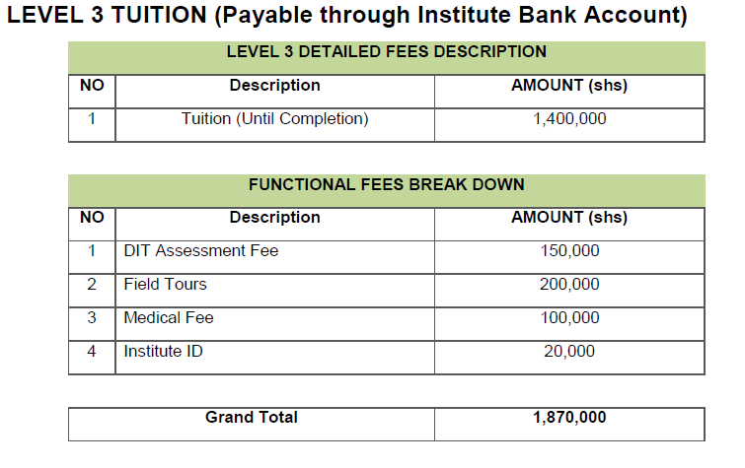
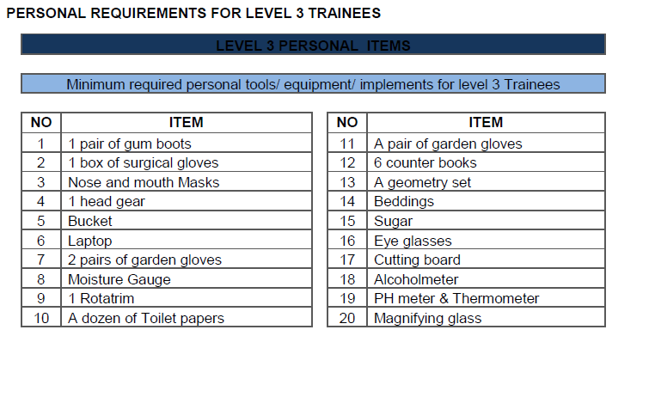
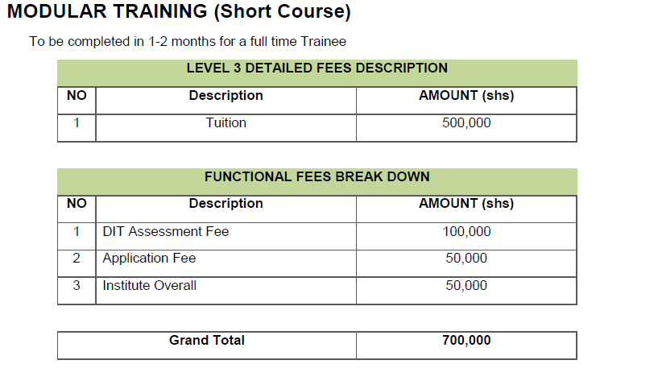
Declaration
I declare that the information that l have provided on this form is complete and accurate. I will notify the administration in case of any changes in regard to the provide information on this form.
INFORMATION COLLECTED
The information collected will be used for students record , determination of residency ,for staff and administration obligation to provide the student with an education program that meets their needs , provide safe and secure learning environment and other purposes related directly to and are necessary for operating program / activity , contact and health related information in the event of problems or emergencies .Also personal information may be provided to the ministry of education and sports for purposes of carrying out programs ,activities and policies.

For the student
I …………………………………………….. has read the rule and regulations, and promise to abide by them.
…………………………………………………………………. …………………………… Signature Date
For the Guardian
I ……………………………………………………. has properly guided and prepared the above student in filling this form. And the information provided is correct and can be used for reference.
……………………………………………………………………... …………………………………
Signature Date
FOR OFFICIAL USE ONLY
This section is filled by the institute administrator who has received and filed this application form
Administrator Name | Position | Signature | Date

Approved and reviewed by
…………………………………………………………
Turyamuhikira Edson
Principal

